Circle the same picture

|  |  |
| --- | --- |
|  |  |
|  |  |
|  |  |
|  |  |
|  |  |
|  |  |

Circle the same picture 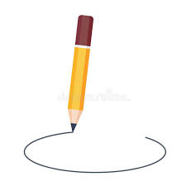

|  |  |
| --- | --- |
|  |  |
|  |  |
|  |  |

Circle the same picture 

|  |  |
| --- | --- |
|  |  |
|  |  |
|  |  |

Fill in the missing letters

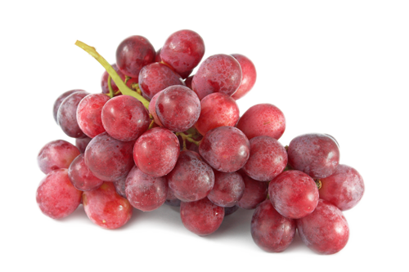 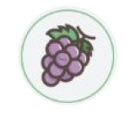

grapes g _ _ _ _ _

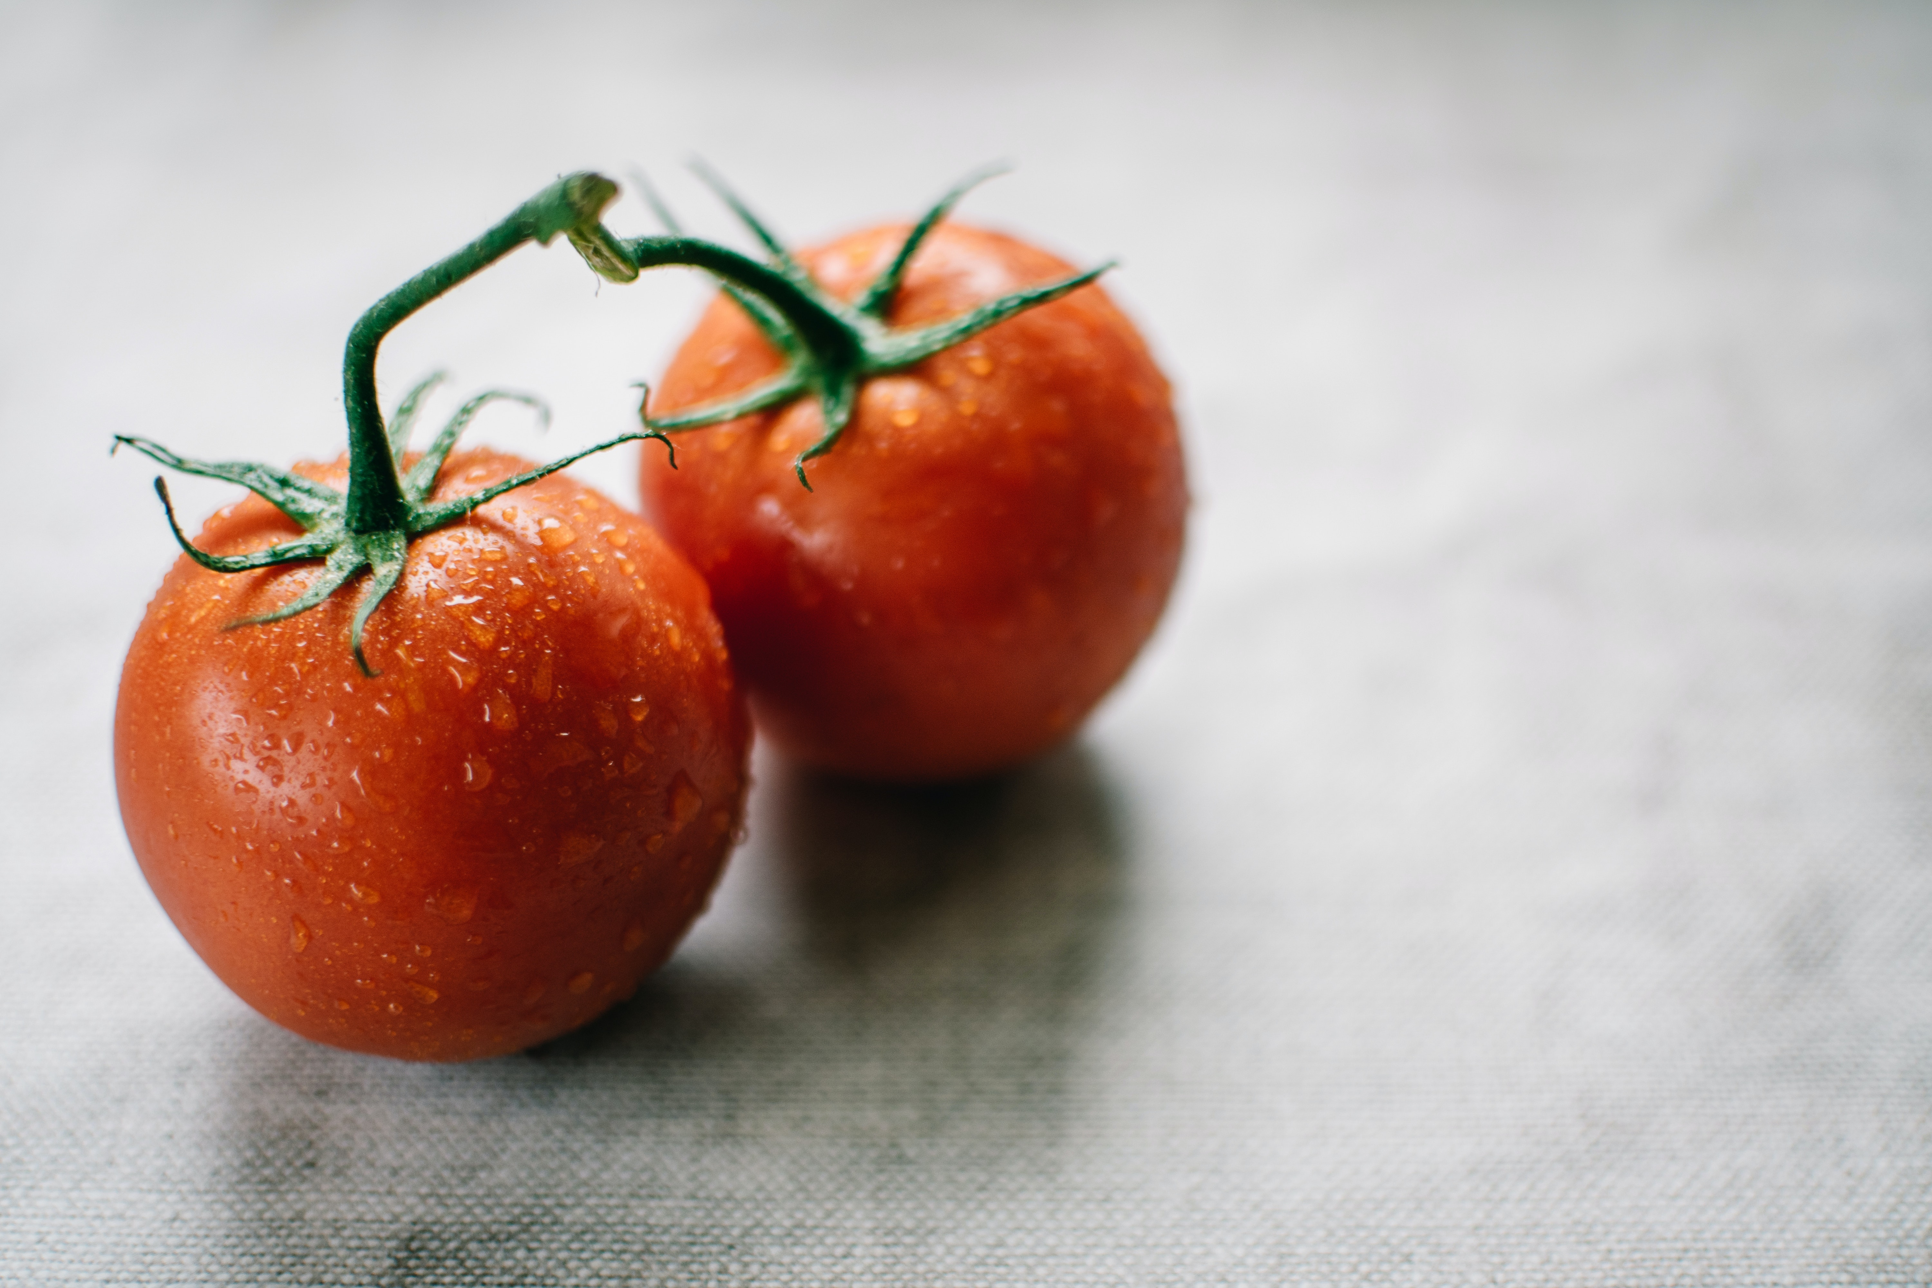 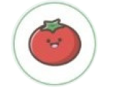

tomatoes t _ _ _ _ _ _ _

Copy

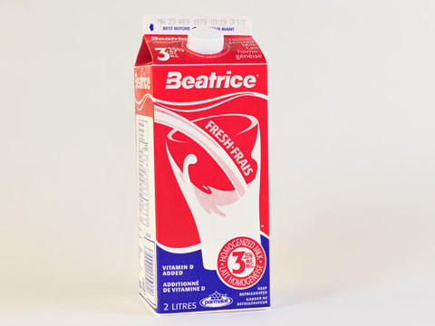 

milk _______________

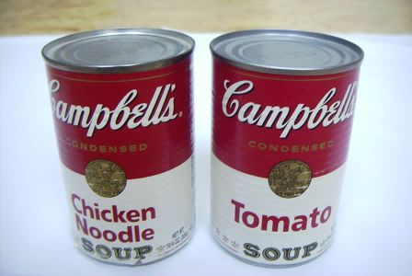 

soup ______________

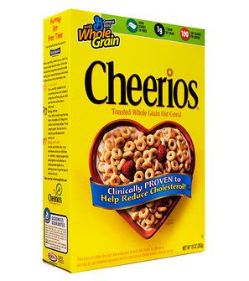 

cereal _____________