Make your own Memory Map
Think about a place: a village, a town, a city, a park or any place that is special to you.

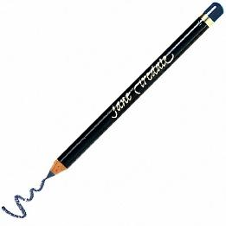
Draw a map from your memory of that special place. Fast and simple is great – just 15-20 minutes!

Talk about your map to someone.
- What did you draw?
- Where is this place?
- When were you there?
- What makes it special to you?
WRITE about your memory map.
Put your memories that you talked about above into full sentences.

Lower Levels
MEMORY MAPS - SELF ASSESSMENT
Check all the boxes you agree with.
This Photo by Unknown Author is licensed under CC BY-SA
In this memory map activity, I showed that I CAN….
- understand instructions.
- give information.
- talk about my family.
- describe things.
- answer questions about myself.
- write complete sentences about myself and my family.

--------------------------------------------------------------------------------------------------------------
Higher Levels
MEMORY MAPS - SELF ASSESSMENT
Check all the boxes you agree with.
This Photo by Unknown Author is licensed under CC BY-SA
In this memory map activity, I showed that I CAN….
- understand instructions.
- provide accurate and detailed information.
- participate in a discussion where I express my opinion and ask for clarification.
- use a variety of complex sentences. I sound fluent when I speak, and people don’t usually have trouble understanding my grammar and pronunciation.
- write a detailed description of people, places, things, and objects.
- write sentences with good control of simple structures and spelling.

